Junior / Senior Timeline
March
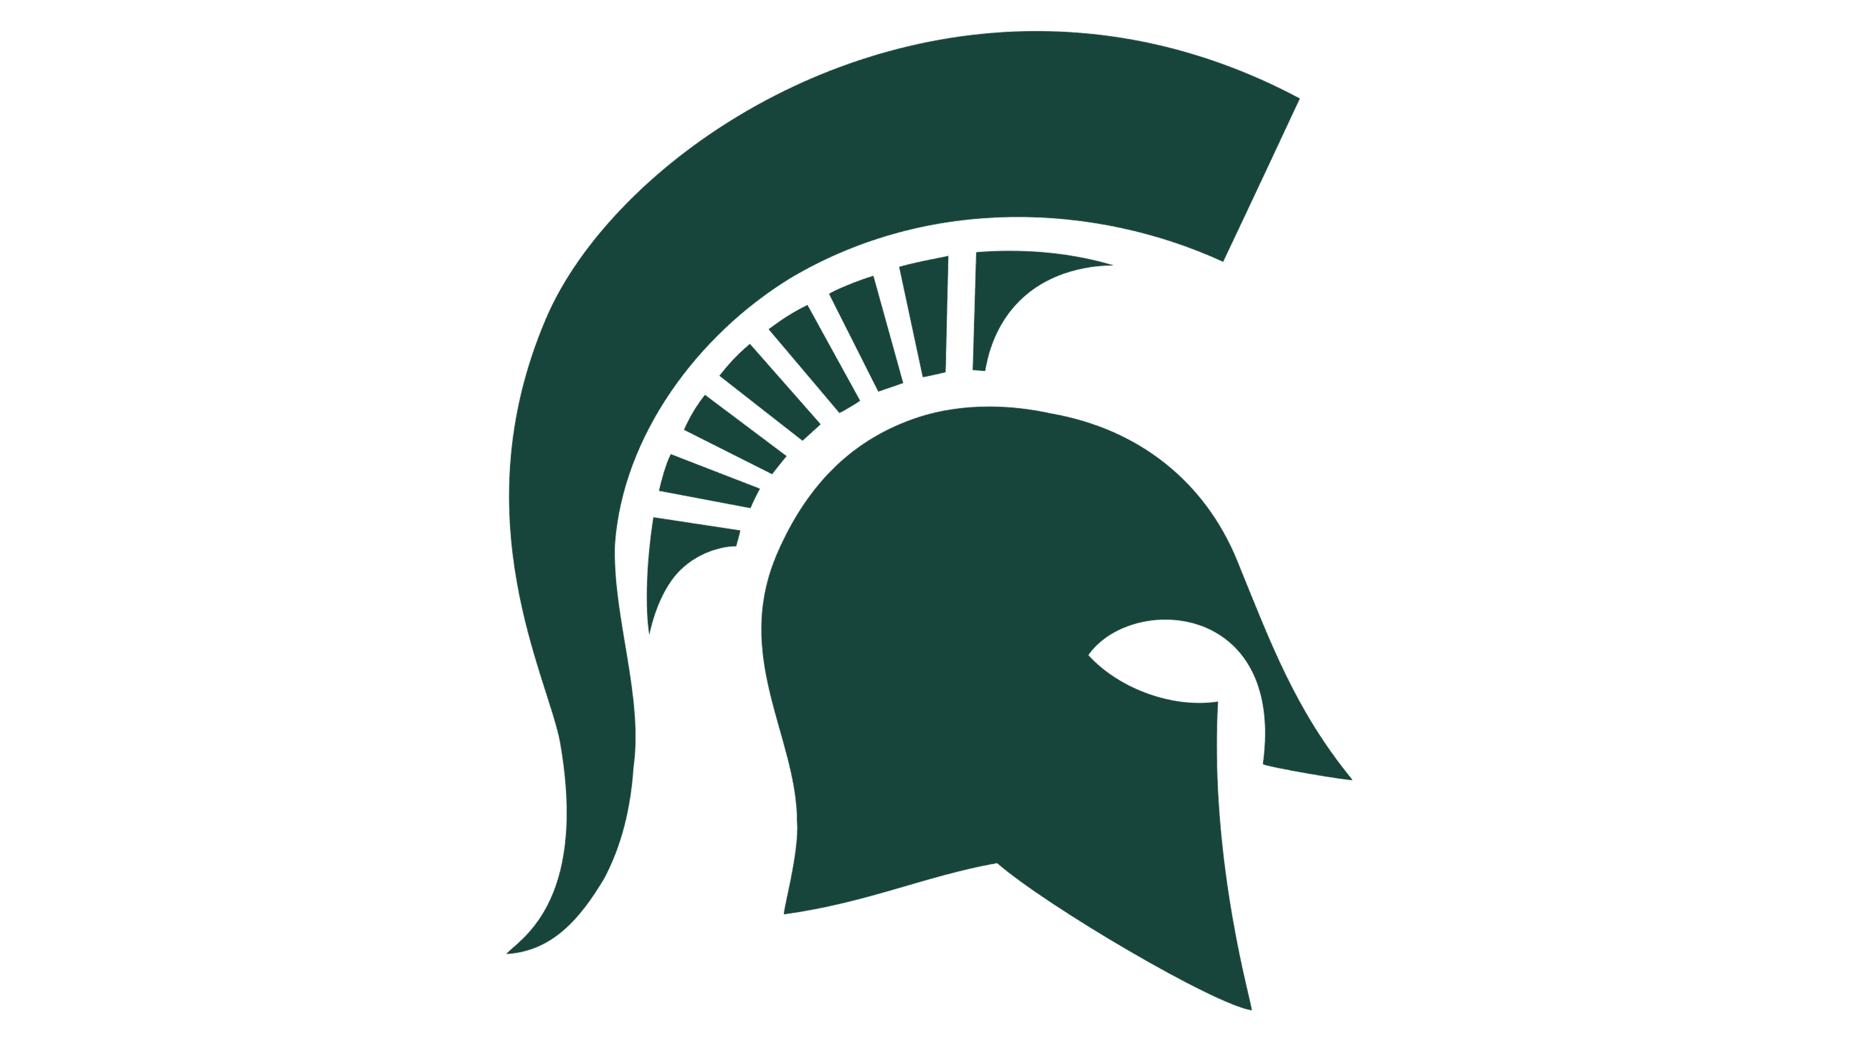
Visit Colleges during Spring Break
Complete Naviance SuperMatch
April / May
Complete Resume
Student Brag Sheet
Parent Brag Sheet
May Resources
Naviance | Access thru SHS Homepage (green button)
FERPA Statement | Skyward – Custom Forms - FERPA Statement
Brag Sheets | SHS Homepage – Counselors – Grade Level Info/Resources – Senior Year (very bottom of page)
Apply Texas Application (for state colleges) | www.applytexas.org
Common App Application (for out of state and private colleges) | www.commonapp.org
SAT | www.collegeboard.com
ACT | www.act.org
FAFSA | https://studentaid.gov

Research Colleges – Do they REALLY require letters of recommendation?
Ask Teachers (1-2) for Letters of Recommendation
June
College Visits
ACT / SAT – take an additional test for practice
Work on College Essays
July/August
College Visits
Complete College Essays
Complete College Applications (Apply Texas / Common App / Direct to Institution)
Sign FERPA in Skyward
Request Transcripts in Naviance – updated transcripts will be uploaded by Sept. 1st after all schedule changes have been completed.
September
Finalize College Applications
Request Transcripts
Complete Class Rank Form – ONLY if it benefits you (Valedictorians)
Apply for FAFSA ID# - (student & parent)
October
Complete FAFSA online
October thru April
Final College Visits
Apply for Scholarships

